Brett Davis, MS
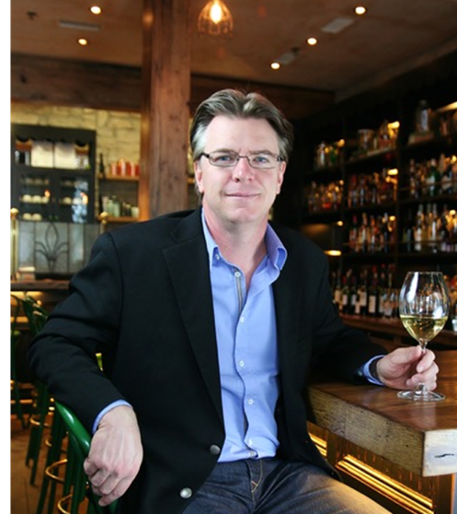
A Knoxville, Tennessee native, Brett began his culinary journey as a line cook at age 15. By 18, he moved to New Orleans to join the service team at the acclaimed Commander’s Palace, where he developed foundational skills that propelled him into leadership roles at renowned establishments such as Michael’s in Santa Monica and Geronimo in Santa Fe. Brett later served as founding partner and COO of Falls City Hospitality Group, where he led concept and design development for multiple restaurant ventures in Louisville and Nashville.

Brett spent a decade as Sales Director for Vintner Select), overseeing a diverse portfolio distributed across Ohio, Indiana, and Kentucky. In 2018, he joined Gallo as National Sales & Education Manager of Lux Wines and was subsequently promoted to National Director of Luxury Sales. He now brings his expertise as National Sales Director of Accendo Estate in Napa Valley.

In 2009, Brett passed the Court of Master Sommeliers’ diploma level exam and became the 100thindividual in the US to earn the title of Master Sommelier. As of 2025, only 282 individuals worldwide have earned this certification over its fifty-five-year history.

Beyond his primary roles, Brett is a sought-after public speaker and educator as well as a consultant for wineries, restaurants, and wholesalers nationwide. He also regularly lectures and proctors exams for candidates pursuing Court of Master Sommeliers certification, continuing to shape the next generation of industry professionals.

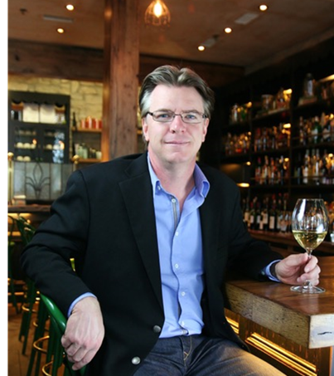
Brett Davis, MS
Brett began his culinary career at 15 and rose into leadership roles at nationally acclaimed restaurants like Commander’s Palace (New Orleans), Michael’s (Santa Monica), and Geronimo (Santa Fe). As the founding partner and COO of Falls City Hospitality Group, he developed multiple restaurant concepts across Louisville and Nashville.

Brett spent ten years as Sales Director with Vintner Select and later joined Gallo, advancing to National Director of Luxury Sales before moving to his current role as National Sales Director of Accendo Estate in Napa Valley.

In 2009, he became the 100th U.S. Master Sommelier - a distinction held by just 282 people worldwide as of 2025. He is also an in-demand speaker, educator, and consultant, mentoring the next generation of wine and hospitality professionals.

