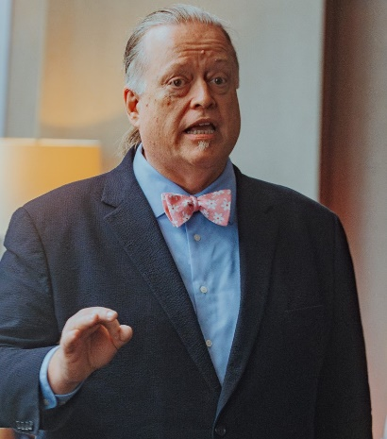
Larry has over 30 years of experience in the restaurant and wine businesses. His wine career hardly seems likely as it began as a Teamster casual worker for a beer and wine wholesaler in Youngstown, Ohio. While the beginnings were humble, Larry earned opportunities at Bern’s Steak House in Tampa, FL, Emeril’s in New Orleans and Orlando, FL and Station Casinos and Resorts in Las Vegas, NV.
In 2010, Larry joined Jackson Family Wines, a career-defining opportunity. He travels extensively and works closely with Jackson Family’s distributor partners to deliver sales results for both retail and restaurant accounts.
Larry represented the United States in the prestigious international sommelier competition Meilleur Sommelier du Monde Concours Mondial in 2000 after winning the title of Best Sommelier in America earlier that same year. In 2001, he became one of approximately 190 Master Sommeliers in the world and the first Master Sommelier in Florida. He has sat on the Board of Directors of the Court of Master Sommeliers. He has served as a judge for the Confrerie de la Chaine des Rotisseurs’ Jeuene Sommelier Competition at the national and regional levels. He has participated as a wine judge, with other internationally recognized experts, at the Starwine International Wine Competition and the TEXSOM International Wine Awards, formerly the Dallas Morning News Wine Competition.
If he had the skill, Larry would give up all this wine drama for a chance to join the Professional Bowlers Association.

