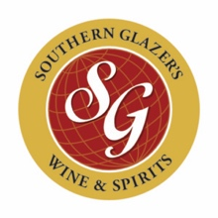

Matthew Citriglia, fka MS
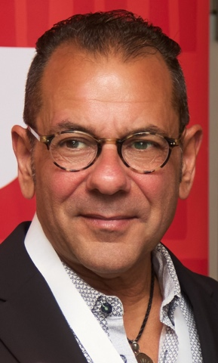
Matthew Citriglia is the Director of Wine Education for the East Region, where he leads wine and spirits education programs. His curricula are designed to help sales consultants build both commercial acumen and consultative expertise.
Across more than forty years of on- and off-premise experience, Matthew has earned numerous credentials from leading organizations, including the Wine & Spirits Education Trust, Court of Master Sommeliers, Wine Scholar Guild, and the Sake Professional Program. He is deeply committed to developing talent—mentoring aspiring beverage professionals and offering practical career guidance. Known for his relentless pursuit of excellence, Matthew is equally respected for his unwavering commitment to hospitality: serving others with integrity and humility.
When he’s not selling or teaching, Matthew can be found defying gravity on a yoga mat, hiking 14ers, spending time with his granddaughters, and enjoying Champagne from a flute.

